Assignment 1 – Tooling

CIS 152

# *Note about Software Tools Going Forward

The world of web design and web development is chock full of commercial, open-source, and custom software tools that attempt to make you more efficient at your work. Some tools succeed at that goal and others don’t, but for the most part the tools you use come down to personal preference. In this course, we will encourage the use and exploration of web design and development tools, and we will encourage the use of some specific ones for course content consistency purposes. However, we will not spend any significant effort providing tutorials and write-ups on how to use specific tools. The internet and its family of search engines should be able to provide you with a bevy of resources on how to use any tools that you desire to become familiar with.

# Instructions

1. Download and extract the assignment1.zip file from cobra to a folder on your machine.
2. Open the folder with your chosen text editor or development tool, then open the index.html file with your preferred web browser.
3. Find the ‘content.txt’ file, and copy the contents of it. Edit the ‘index.html’ and place the content that you just copied inside the <body></body> element.
4. Refresh your web browser to ensure that you are now looking at blog article. Be sure the image in the middle of the article shows up.
5. Once you’ve confirmed the changes have been updated in your index.html file, open the developer tools for the browser you are working in and use the element inspector to find the article title of the page.

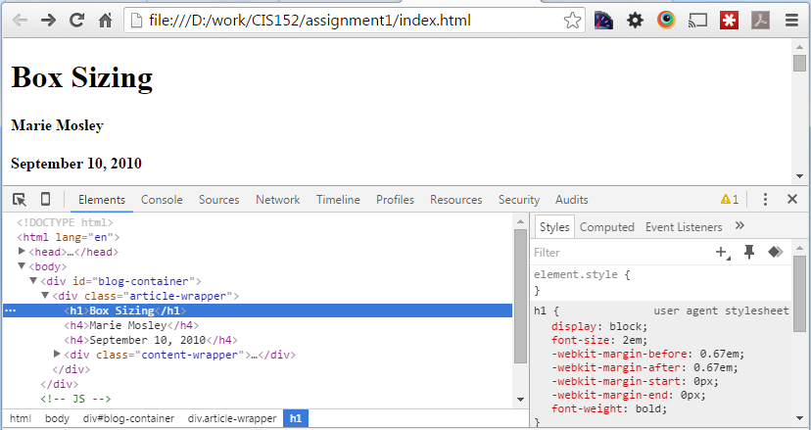

1. Using the “styles” pane in your development tools window, set the following style properties of the <h1> article title:
   1. Width: 300px
   2. Height: 150px
   3. Background-color: green

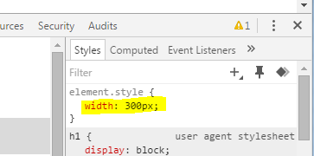

(just click in the area and start typing)

1. Change the ‘color’ of the Author’s name to ‘purple’.
2. Change the html text of the article date to have the current year.
3. Change the article title to say “Box Sizing – according to FIRSTNAME LASTNAME”
4. Take a screenshot of your browser window with your developer toolbar showing, and showing the changes you just made. Save the screen shot as “assignment1_LAST_FIRST.png” (replace LAST and FIRST with your name), and submit to Cobra.